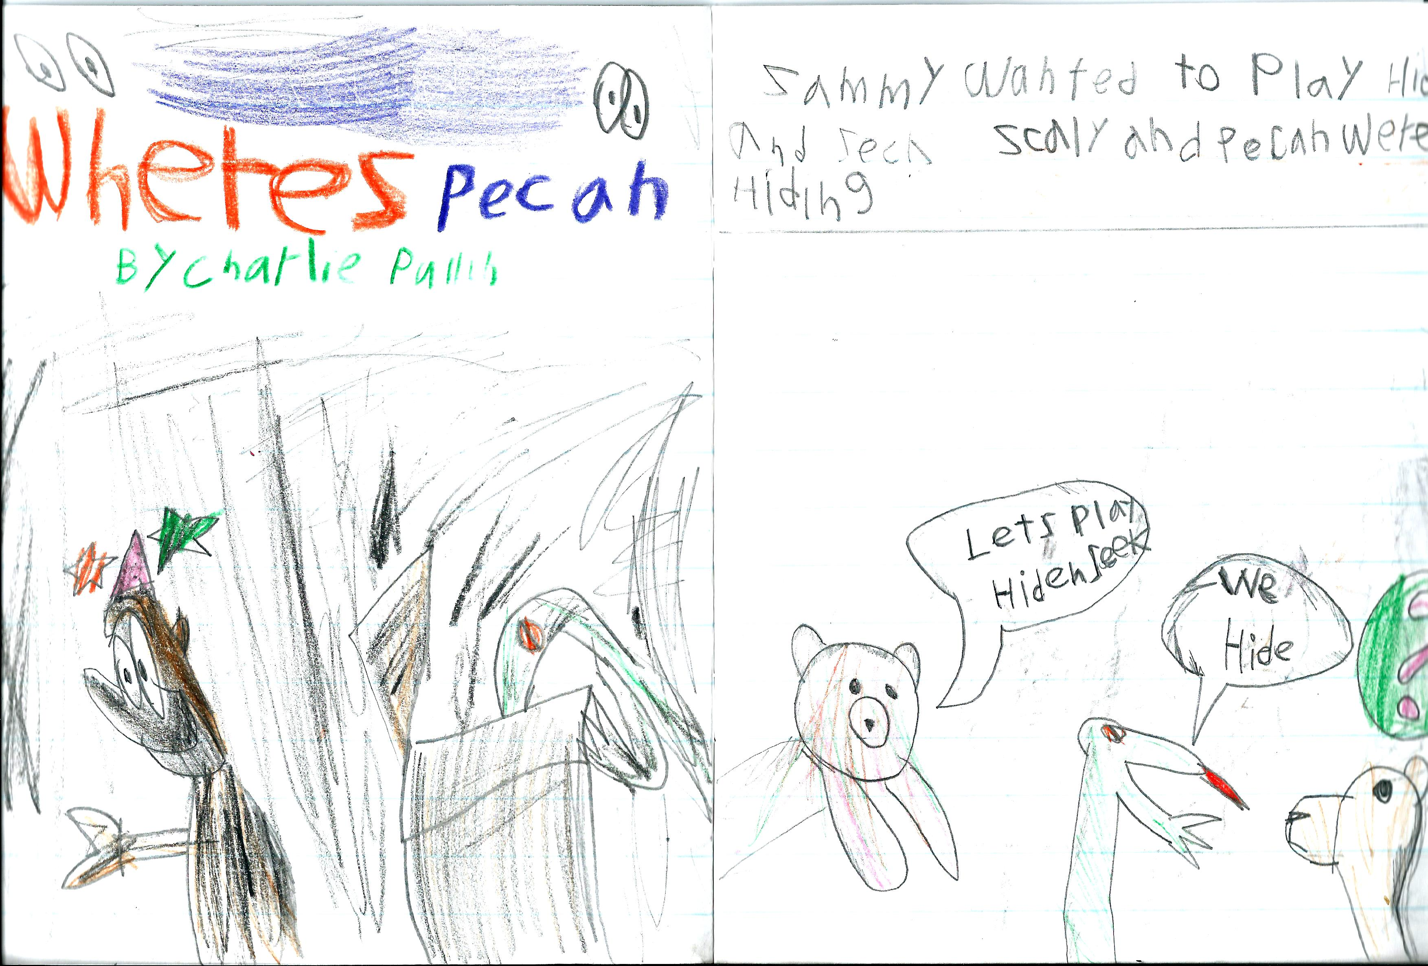 | 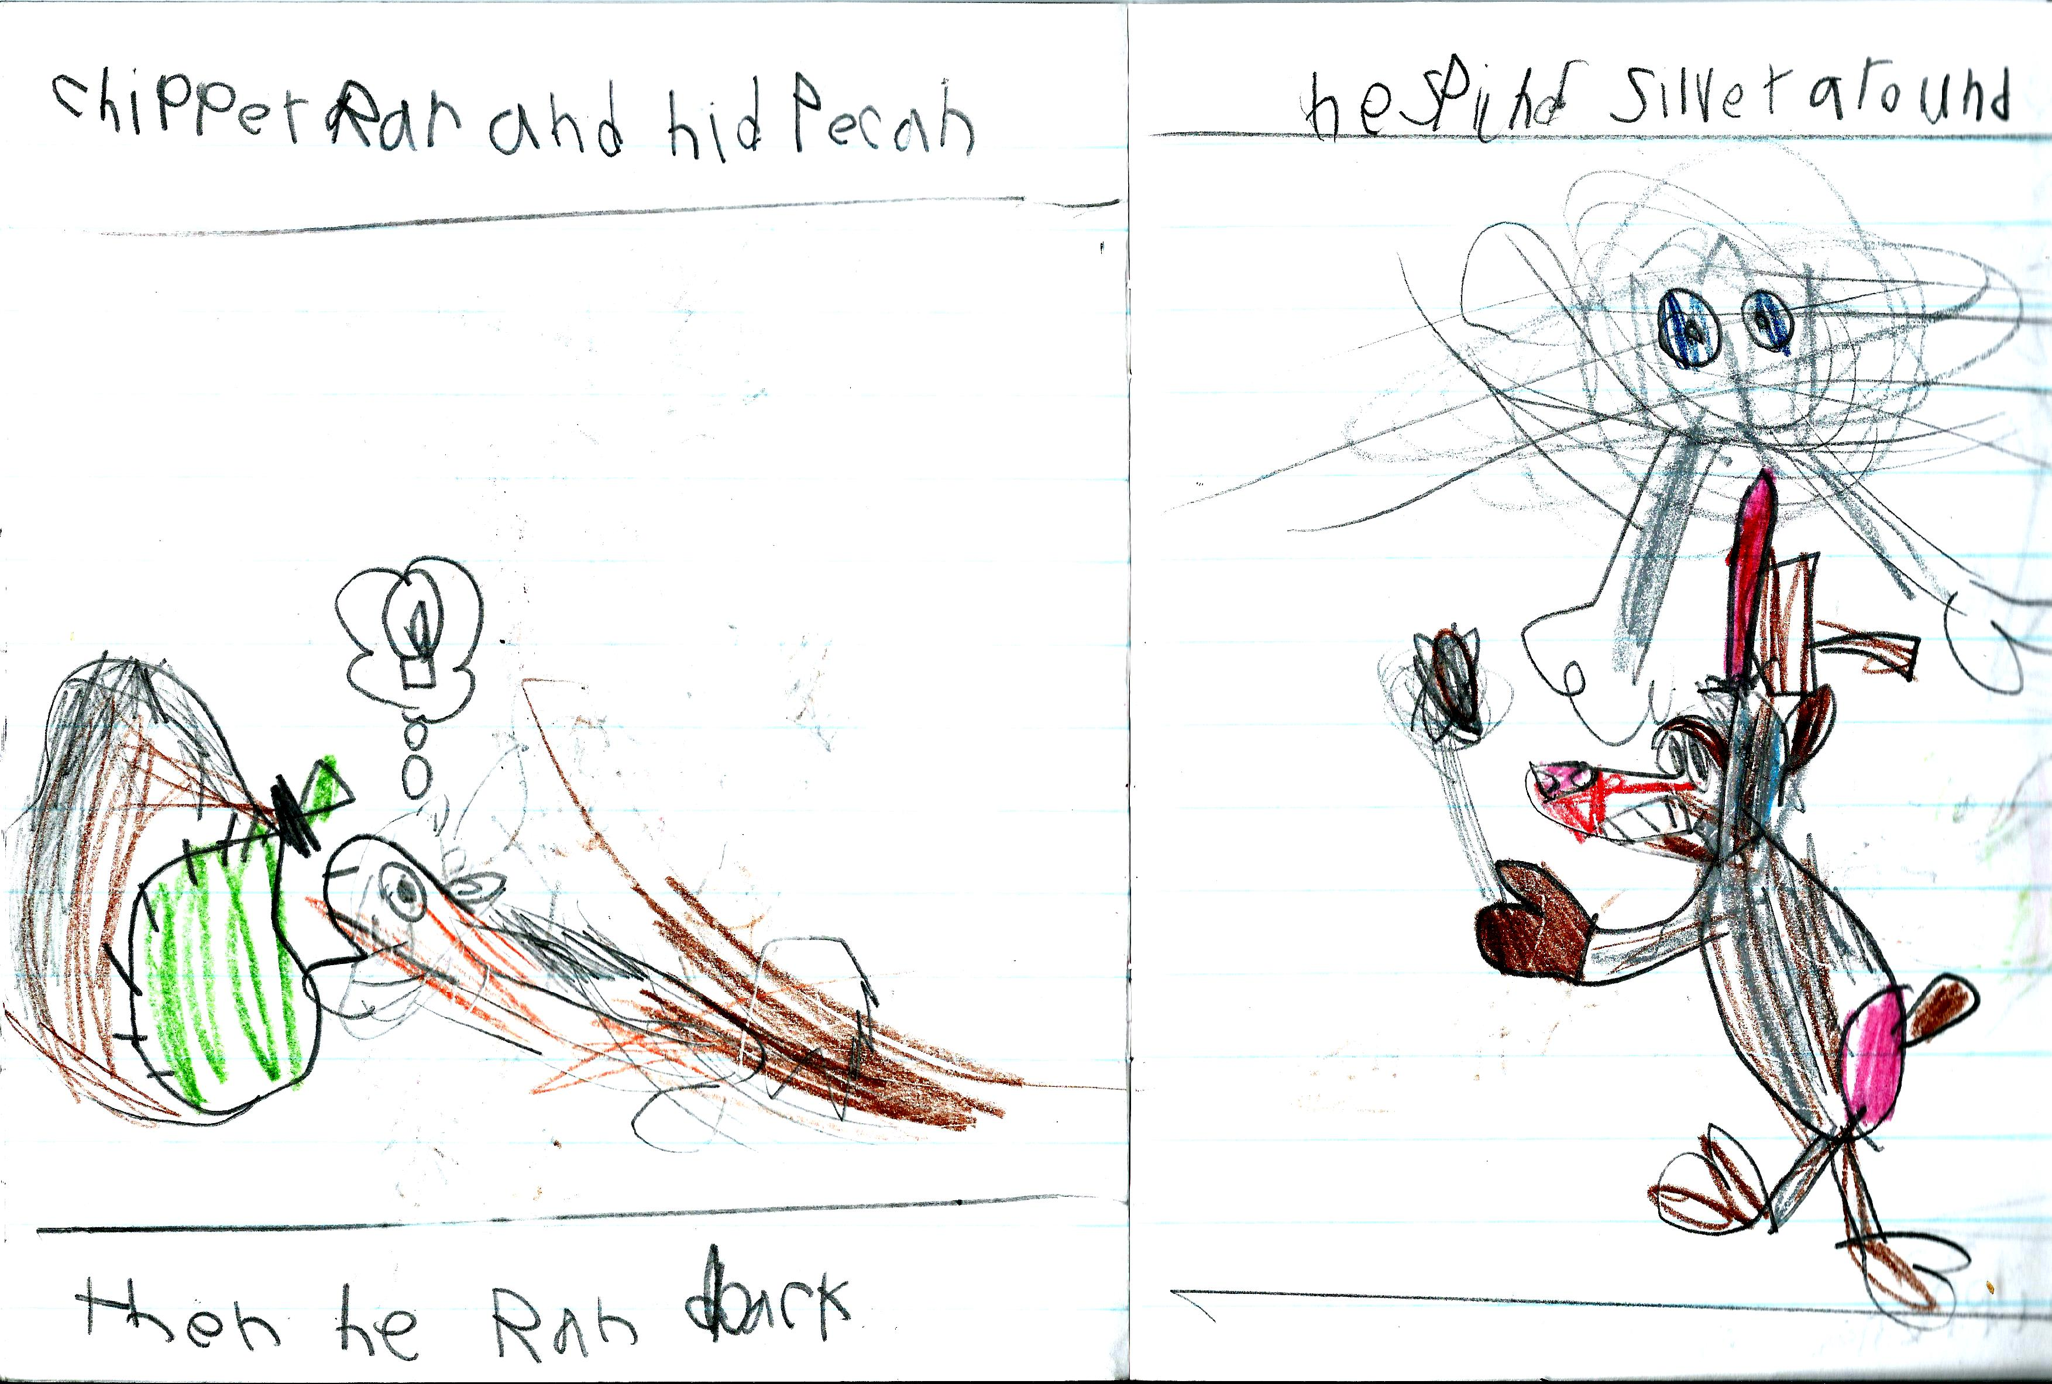
‘Where’s Pecan?’ by Charlie Pullin  Sammy wanted to play Hide and Seek. Scaly and Pecan were hiding. “Let’s play Hide and Seek.” “We Hide” | Chipper ran and hid Pecan, then he ran back. He spinned Silver around.

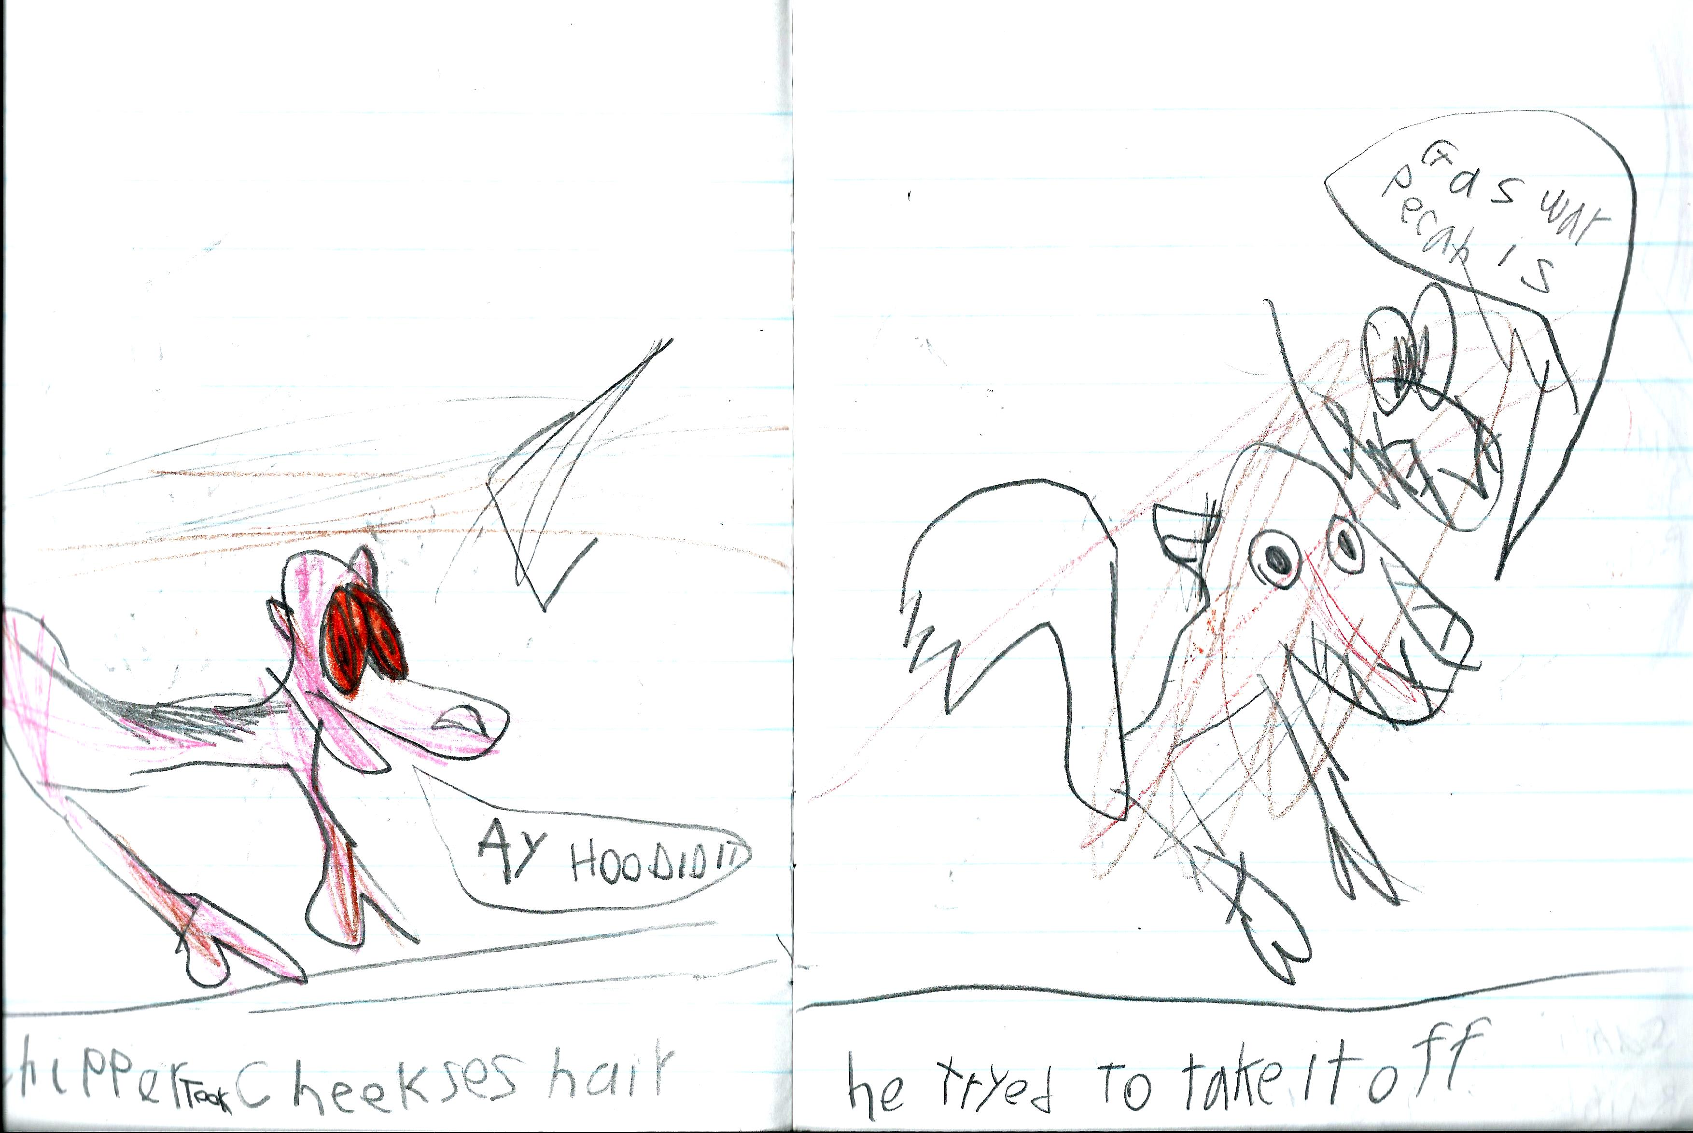 | 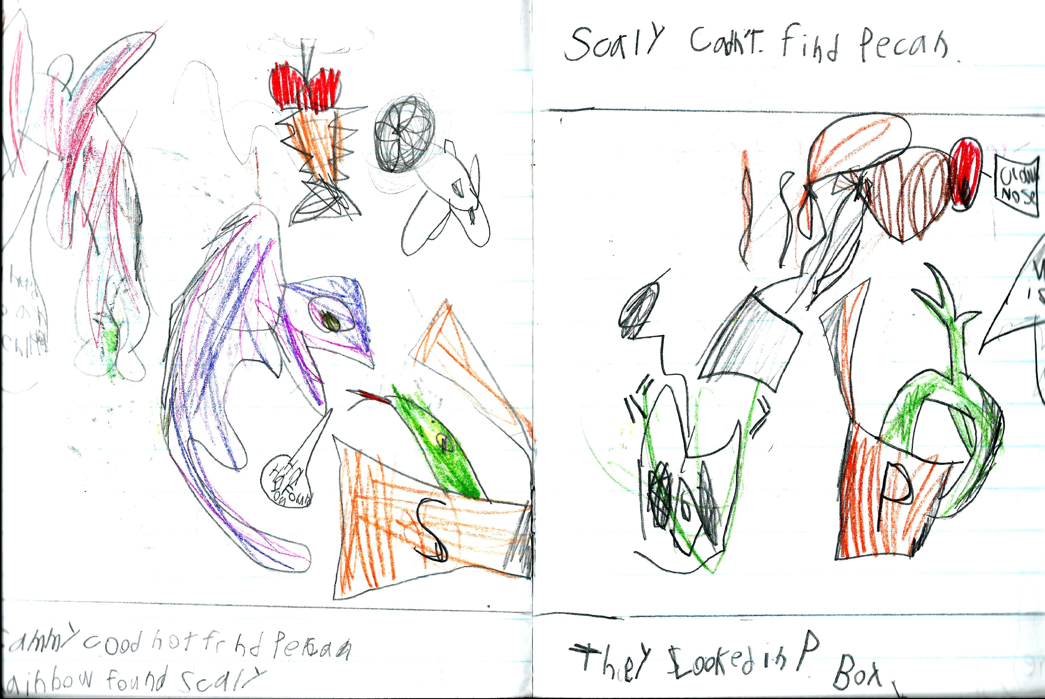
Chipper took Cheeks’ hair. “Ay Hoo did it?” He tried to take it off. “Guess where pecan is!” says Cheeks. | Sammy could not find Pecan. Rainbow and Scaly looked. Scaly can’t find Pecan. They looked in the ‘P’ box.

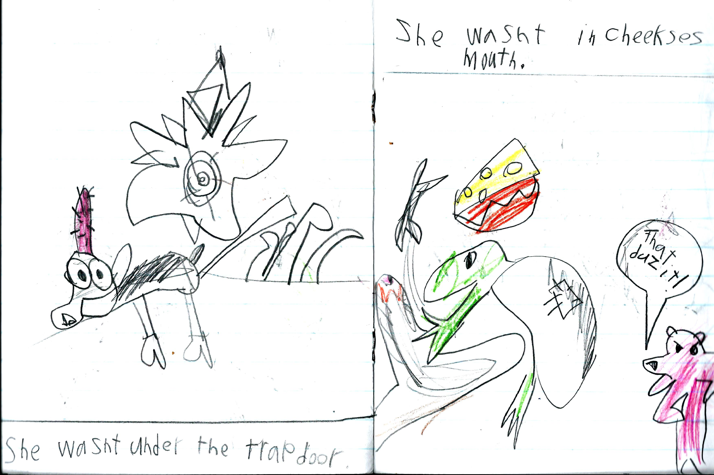 | 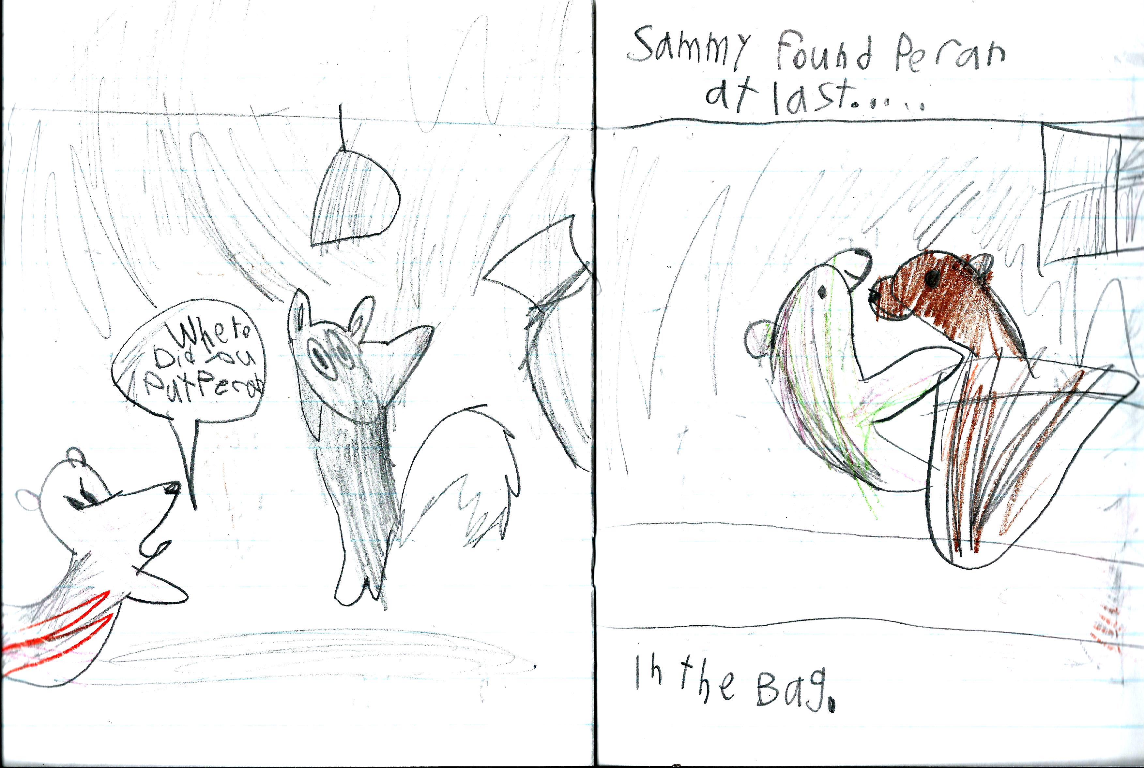
She wasn’t under the trap-door. She wasn’t in Cheeks’ mouth. “That duz it!” said Sammy. | “Where did you put Pecan?” said Sammy. Sammy found Pecan at last…… in the bag.

